Job Description & Person Specification
Position: Project Manager
Reports To: Assistant Director - Major Projects
Salary Range: £50,000 to £55,000 per annum
Contract: Fixed Term (2 years, with option to extend by 1 year)
Hours Per week: 35

Our Values and Behaviours
To act in accordance with “Our Values and Behaviours” at all times when delivering your role, ensuring that “Kindness”, “Respect”, “Belonging”, and “Empowerment” are fundamental to your behaviour.
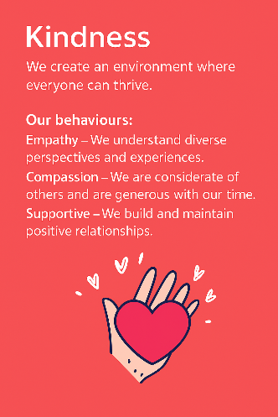
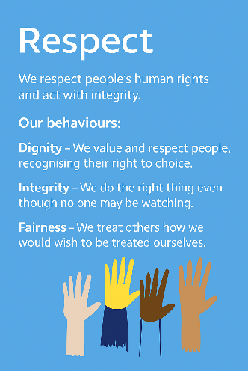
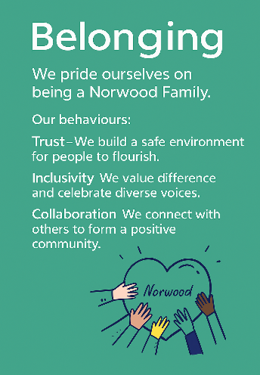
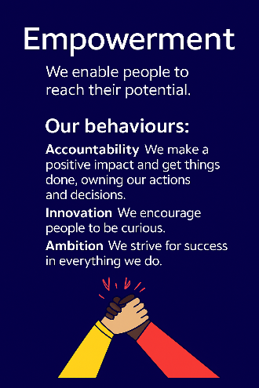
Empowerment
Respect
Belonging
Kindness

Policies and Procedures
In addition to undertaking the accountabilities as outlined below, the post holder will be expected to fully adhere to all Norwood policies and procedures which are referenced in the employment contract and Norwood's intranet.
Role Summary
The Project Manager will support the Assistant Director of Major Projects to deliver a diverse portfolio of capital development, digital transformation, and organisational change projects. This role ensures projects are delivered safely, on time, within budget, and to a high standard that reflects the organisation’s values and the needs of people who use our services.
The postholder will work collaboratively with internal teams, external consultants, contractors, commissioners, and people with lived experience to ensure successful project outcomes.
Key Accountabilities
1. Project Management
- Lead day-to-day management of allocated projects, ensuring delivery against scope, budget, quality, and timelines.
- Develop and maintain project plans, risk logs, milestone trackers, and project reporting documentation.
- Support the development of business cases and project proposals.
- Support the development of policy and procedures for effective feasibility, initiation, and management and delivery of projects.
- Monitor performance against objectives and escalate risks or issues appropriately.
2. Capital Projects
- Support the delivery of new-build, refurbishment, and adaptation projects for residential and supported living settings.
- Coordinate external professional teams (architects, surveyors, planners, contractors).
- Ensure compliance with regulatory requirements including CQC, health and safety, planning, and building regulations.
- Engage with staff and people supported to ensure accommodation is designed to meet neurodiverse needs.
3. Digital and Technology Transformation
- Assist with the implementation of new technology systems, including care management systems, digital infrastructure, and assistive technologies.
- Work with IT and external suppliers to support procurement, testing, deployment, and user training.
- Ensure technology change supports service improvement and organisational efficiency.
4. Organisational Change
- Support change programmes that improve service models, operations, and workforce development.
- Facilitate workshops, consultations, and change impact assessments across services.
- Work with People & Culture, Operations, and Communications to deliver effective change management and staff engagement.
5. Stakeholder Engagement
- Build strong relationships with internal colleagues, external partners, people we support, and their families.
- Prepare project briefings, reports, presentations, and updates for senior management and boards.
- Ensure co-production principles are embedded in project planning and delivery.
6. Governance and Compliance
- Maintain rigorous project documentation and audit trails.
- Ensure procurement follows organisational policies and value-for-money principles.
- Promote safe and inclusive design practices that reflect neurodiversity-informed environments.

Person Specification
 | Essential | Desirable | Evidence
Qualification(s) | - Professional experience in project management.  - Training or certification in project management methodologies (e.g., PRINCE2, APM, Agile) or willingness to obtain. | - Degree in project management, construction, business, social care, or a related field.  - Membership of APM or similar professional body. | Cover Letter / CV / Onboarding
Experience | - Experience delivering projects in one or more of the following:  - capital or property development  - digital transformation  - organisational change  - Experience managing multiple projects concurrently.  - Experience working with diverse stakeholders and managing external suppliers.  - Experience in not-for-profit, public sector, housing, health, or social care settings. | - Experience in the care sector, especially neurodiversity, learning disability, or supported living.  - Experience with service user co-production and inclusive design.  - Experience working with construction professionals or contractors. | CV / Interview / Onboarding
Knowledge & Training | - Strong project planning, risk management, and organisational skills.  - Ability to prepare and deliver clear reports and presentations.  - Knowledge of project governance, budget monitoring, and procurement.  - Excellent communication, negotiation, and relationship-building skills.  - Ability to influence and engage colleagues at all levels.  - Understanding of safeguarding, health and safety, and compliance principles. | - Knowledge of CQC requirements, supported housing regulations, and neurodiversity-informed design principles.  - Understanding of assistive technology or digital solutions for care settings. | Cover Letter / CV / Interview / Presentation
Personal Qualities & Attributes | - Commitment to the values of inclusion, co-production, and person-centred care.  - Empathy and respect for people with neurodiversity.  - Proactive, solution-focused, and adaptable.  - Comfortable working in a fast-paced, change-oriented environment.  - Ability to work independently and as part of a collaborative team.  - High level of integrity and professionalism. | - | Cover Letter / CV / Interview
All roles require a DBS check and satisfactory clearance under Norwood’s safer recruitment policies. We are committed to safeguarding the wellbeing of our people and maintaining a respectful, safe environment.
This job description is not exhaustive and may be updated as accountabilities evolve.

