Job Description & Person Specification
Position: Assistant Chef
Reports To: Head chef

Our Values and Behaviours
To act in accordance with “Our Values and Behaviours” at all times when delivering your role, ensuring that “Kindness”, “Respect”, “Belonging”, and “Empowerment” are fundamental to your behaviour.
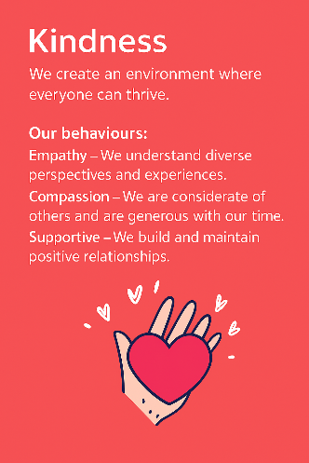
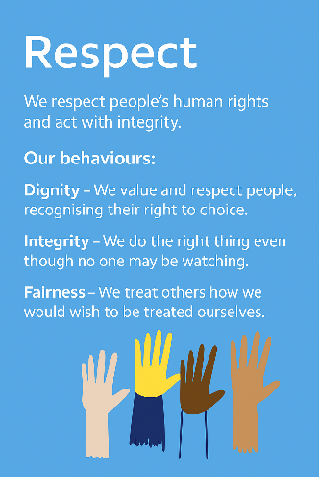
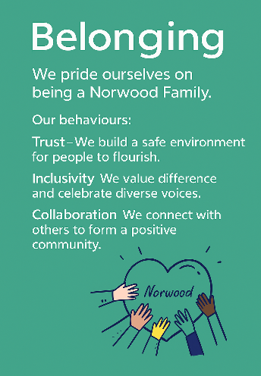
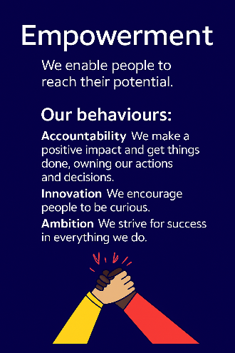
Empowerment
Respect
Belonging
Kindness

Policies and Procedures
In addition to undertaking the accountabilities as outlined below, the post holder will be expected to fully adhere to all Norwood policies and procedures which are referenced in the employment contract and Norwood's intranet.
Role Summary
The Assistant Chef supports the preparation and service of safe, nutritious meals in line with dietary requirements and Kashrut standards. They help maintain high levels of food hygiene and kitchen cleanliness, ensuring compliance with health, safety, and food regulations. The role also contributes to the smooth day-to-day running of the kitchen, including food handling, stock control, and cleaning.

Key Accountabilities
1. To be part of a team preparing and providing meals which comply with the laws of Kashrut and Food Hygiene Regulations.
2. Prepare and serve safe food for consumption and in accordance with Kosher preparation and cooking of food.
3. To maintain the kitchen cleaning and disposal of waste in accordance with the regulations set by the Food Standards Agency.
4. To prepare and serve well balanced nutritious meals.
5. To clean dining and kitchen areas after meals are served, including sweeping, washing up crockery, cutlery, utensils, pots and pans.
6. To complete periodic deep cleaning of the kitchen as defined in the cleaning schedule.
7. To record, report and action all Health and Safety and Food Standards Agency required checks, including food temperatures, fridge and freezer temperatures, opening and closing checks.
8. To be aware of and comply with the safe working practices as laid down under the Health & Safety at Work Act and Food Hygiene Regulations.

Person Specification
 | Essential | Desirable | Evidence
Qualification(s) – Willing to undertake | Good standard of English |  | Cover Letter / CV / Test
Experience | Experience of working in a catering environment | Knowledge and understanding of working with people with learning disabilities, and Autism | CV / Interview / Onboarding
Knowledge & Training | Knowledge of Health & safety requirements  Knowledge of food hygiene regulations  Ability to work as part of a team  Excellent communication skills  Ability and willingness to take instructions  Willingness to learn about Kosher cookery  Ability to demonstrate flexibility of approach to meet the needs service users | Knowledge of Kosher cookery | Cover Letter / CV / Interview
Personal Qualities & Attributes | High degree of personal integrity with a commitment to confidentiality.  Approachable and aware of self on others  Commitment to Continuous Personal Development (CPD)  Good general health  Knowledge or willingness to learn about Jewish Culture | Able and willing to work flexible hours, including Bank Holidays, to meet service needs  Driver and willing to use own car | Cover Letter / CV / Interview
All roles require a DBS check and satisfactory clearance under Norwood’s safer recruitment policies. We are committed to safeguarding the wellbeing of our people and maintaining a respectful, safe environment.
This job description is not exhaustive and may be updated as accountabilities evolve.

