Job Description & Person Specification
Position: Support Worker
Reports To: Service Manager

Our Values and Behaviours
To act in accordance with “Our Values and Behaviours” at all times when delivering your role, ensuring that “Kindness”, “Respect”, “Belonging”, and “Empowerment” are fundamental to your behaviour.
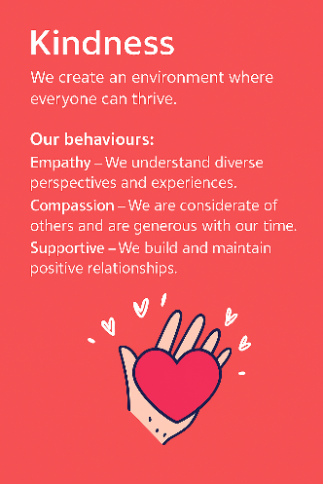
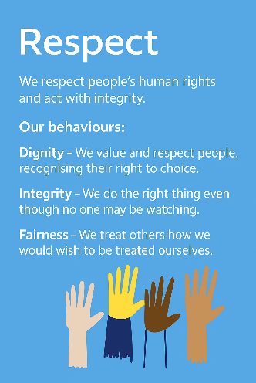
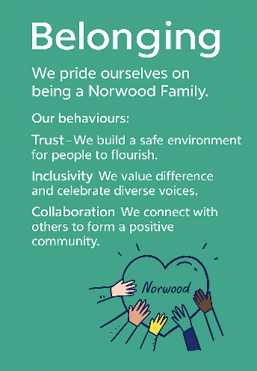
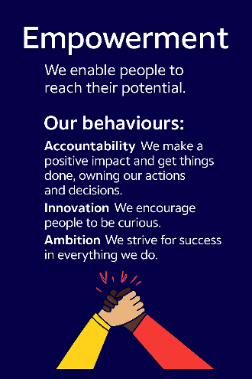
Empowerment
Respect
Belonging
Kindness

Policies and Procedures
In addition to undertaking the accountabilities as outlined below, the post holder will be expected to fully adhere to all Norwood policies and procedures which are referenced in the employment contract and Norwood's intranet.
Role Summary
To contribute to the delivery of care in accordance with the Health and Social care Act 2008 and Policies and Procedures of Norwood. Provide person centred support to adults with learning disabilities living in the care home enabling them to live an ordinary life as active citizens in the community.
Key Accountabilities
- In the context of Norwood’s Policies and Procedures work as part of a team to provide individualised and personalised support to adults with a learning disability within a range of community and accommodation-based settings.
- To work in partnership with the people that we support, the team and all other stakeholders to plan, organise, implement, monitor and review activities to achieve the agreed targets set out in Person Centred Plans, Individual Plans and Health Action Plans.
- To exercise creativity in developing Person Centred Plans (PCP) with the people we support, enabling full participation in the process from setting up circles of support, to carrying out reviews.
- As a Keyworker to be involved in the creation and implementation of Individual Learning Plans (ILPs) in accordance with Norwood’s strategy for Life Long Learning.
- In accordance with individual needs and wishes; enable the people we support to take control of their lives by maximising independence and participation in all personal, social, cultural, educational and employment opportunities.
- Where required, and in accordance with support plans and individual preferences, assist the people we support with all manual handling needs, including the use of manual handling equipment and evacuation chairs.
- Where required, and in accordance with support plans and individual preferences, provide personal care to the people we support maintaining privacy and dignity at all times.
- To administer medication to service users in accordance with individual need and in accordance with Norwood policy and procedures. Take initiative in dealing with emergencies such as medical / challenging situations
- To ensure that the support provided is flexible, individual and underpinned by person centred approaches following the principles of Active Support, Training in Systematic Instruction (TSI) or any other organisationally recognised approach to service delivery.
- Working from PCPs, ensure that all processes and administrative functions are fulfilled to ensure that the outcomes are achieved, including Support and Care Planning, risk and financial management, monitoring, recording and reporting.
Person Specification
 | Essential | Desirable | Evidence
Qualification(s) – Willing to undertake | - Demonstrated foundational skills in Literacy and Numeracy | - NVQ 2 Health & Social Care (Adults)  - Completion of the Skills for Care Induction. | Cover Letter / CV / Onboarding
Experience | - Experience of working collaboratively with other people (paid or unpaid) | - Experience of delivering support using the principles of Applied Behaviour Analysis (ABA).  - Experience of working with people with learning disabilities and autism and/or complex behaviour needs.  - Experience of delivering support using the Positive Behaviour Support framework. | CV / Interview / Onboarding
Knowledge & Training | - Understanding of Learning Disabilities.  - Strong Literacy and Numeracy skills.  - Commitment to an inclusive approach to service planning and delivery.  - Understanding and ability to support people with a range of communication and behavioural needs.  - Ability to be self-motivated and use initiative within a structured framework.  - Ability to communicate effectively with a variety of stakeholders; people we support, families, carers, colleagues and external agencies.  - Able and willing to support with all aspects of domestic and personal care. | • Clean driving licence and willingness to drive Norwood’s vehicles  • Person Centred Planning.  • Person Centred Risk Taking.  • Training in Systematic Instruction.  • Person Centred Approaches and Active Support.  • Understanding and awareness of the Jewish culture.  • Health and Safety at Work.  • Creativity.  • Knowledge of safeguarding Adults, Mental Capacity Act and Deprivation of Liberty Safeguards.  • Good IT skills. | Cover Letter / CV / Interview
Personal Qualities & Attributes | • High degree of personal integrity with a commitment to confidentiality.  • Empathic & understanding, with a positive attitude regarding people with learning disabilities and autism.  • Understanding of and ability to cope with needs of residents i.e. challenging behaviour, physical and emotional needs.  • Ability to meet the physical, emotional, intellectual and leisure needs of people we support, inside and outside of home.  • Commitment to following evidenced based practice. | Ability to support and participate in recreational activities inside and outside the home | Cover Letter / CV / Interview
All roles require a DBS check and satisfactory clearance under Norwood’s safer recruitment policies. We are committed to safeguarding the wellbeing of our people and maintaining a respectful, safe environment.
This job description is not exhaustive and may be updated as accountabilities evolve.

